EXPERIMENT -2

2. Create a simple cloud software application for Flight Reservation System using any Cloud Service Provider to demonstrate SaaS.

- AIM: To create a simple cloud software application for flight reservation system using any cloud service provider to demonstrate saas.
- PROCEDURE:
- step1: Go to zoho.com.
- step 2: Log into the zoho.com.
- step 3: Select one application step.
- step4: Enter application name as flight reservation system.
- step 5: Created new application flight reservation system.
- step 6: Select one form
- step 7: The software has been created.
IMPLEMENTATION:
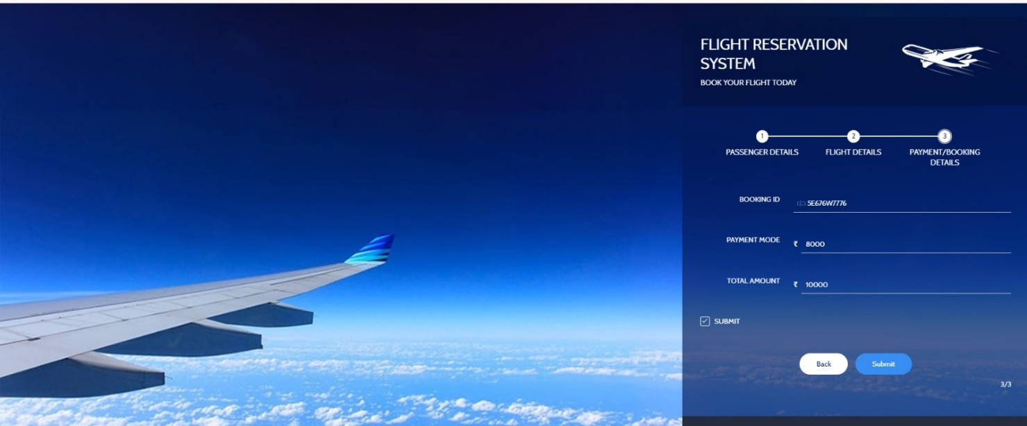

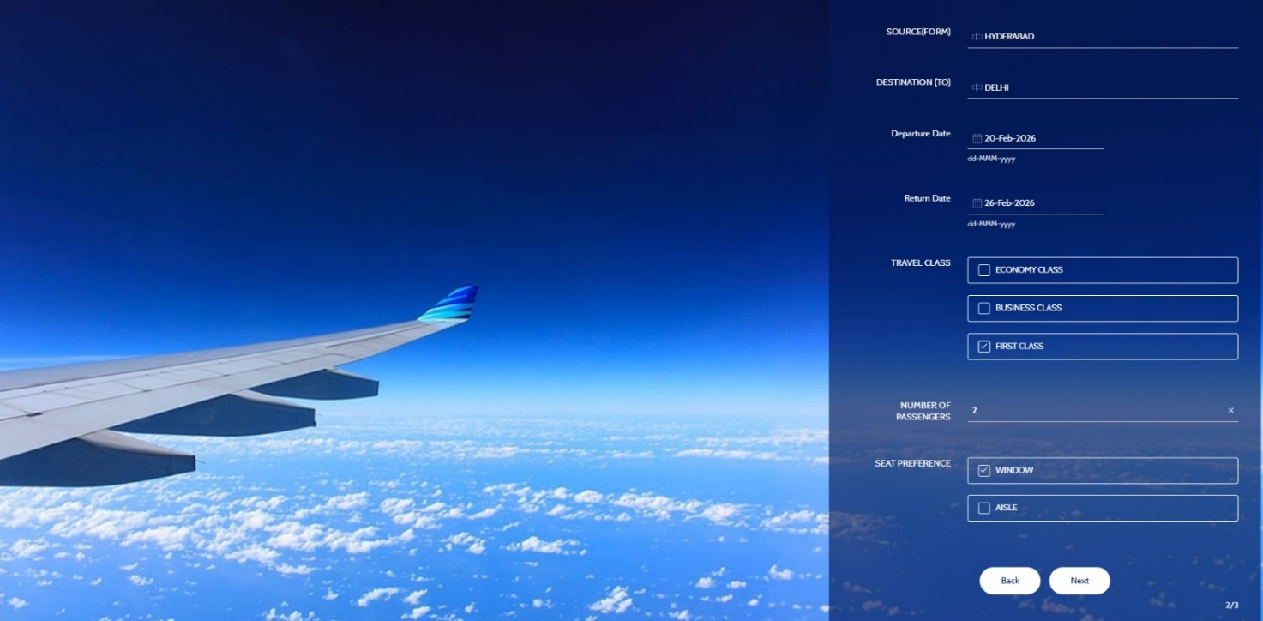

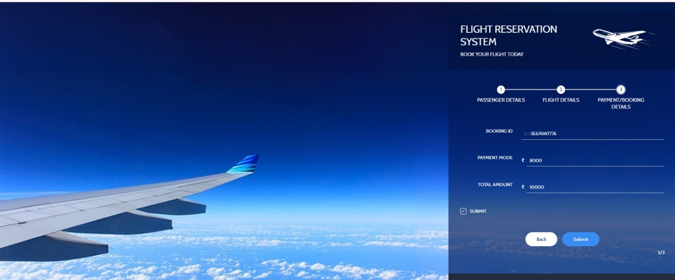

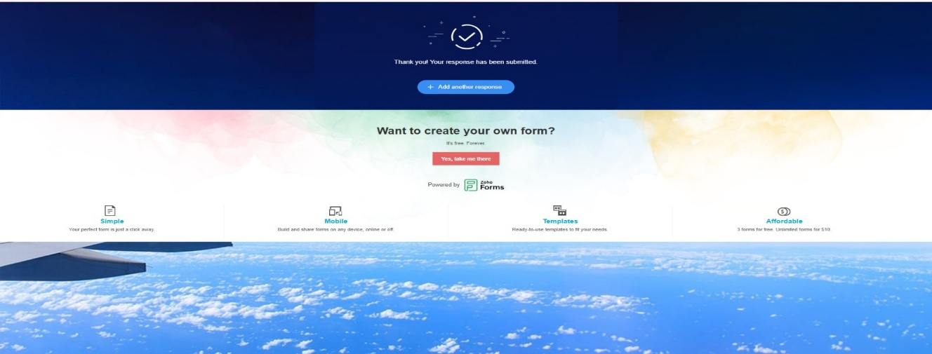

RESULT:
- The Flight Reservation System is successfully deployed on cloud
- Users can:
  - Enter passenger name and flight number
  - Book flight tickets online
  - View all booked flights instantly
- Booking data is stored securely in cloud database
- Application is accessible anytime, anywhere via browser
- No installation required by users
📌 Thus, the application successfully demonstrates Software as a Service (SaaS).

